Agenda - MSTD Executive Committee Meeting
2025 ANS Annual Conference

Monday, June 16, 2025
11 am – 1 pm EST

In person meeting location: Kane

Hybrid meeting option:
Join the teams meeting
Meeting ID: 265 259 807 912
Passcode: xx9QH2ic

- Call to Order (Pimblott)
  - Attendance
    - Division Officers
    - Executive Committee Members
    - Others Present
- Approval of Minutes, MSTD Executive Committee, November 18, 2024 (all)
  - We don’t have them pulled together yet – to be sent later by Mike Tonks
- Updates from the Chair (Pimblott)
  - Presidents Breakfast
    - Unusual presidents breakfast
    - Teams meeting a couple of weeks prior
      - Impact of administration on society
        - Going to 1 meeting per year instead of 2.
        - Will move the Annual meeting to winter meeting
      - Professional certification courses (101)
        - Will run one more time in person before going online
        - Will continue
      - Lots of travel for Lisa
        - Concerns- workforce development, public policy, not clear what will happen with nuclear (messaging is good, where the $$ is coming from is unclear)
        - Nuclear timelines are being accelerated
        - Highlighted the need for positive advocacy- highlighted roles that external affairs committee and ANS plays in this. Nuclear timelines are being accelerated
      - Large growth in conference attendance
        - Over 600 at student conference
        - 1400 at annual meeting
      - Increased interest in nuclear from state governments
      - New ANS office in Westmont, Illinois is now up and running
  - PDC Meeting
    - With the move to a single annual meeting, the opportunity for embedded topics will be less
      - Typically MSTD runs an embedded topical alternating years with MiNES
      - 2027 embedded was approved at the NPC Screening meeting
  - NPC Screening Meeting
- Secretary-Treasurer’s Report (Tonks)
  - Budget (1/1/25-3/31/2025)
    - $2000 in expenses (support for student meeting)
    - $392 in revenue
    - Still at a healthy budget $82,140
    - Scholarship fund established in the past, there’s $47k in the endowed fund, and we’re limited by what we can pay out based on the budgetary model for the endowment
      - This year allowed expenditure of $2,794- can ask the board to help here to cover the difference for the $3k scholarship
    - Other uses: lunch at meetings, social similar to 2024 annual meeting, open to other ideas for how to use these funds
    - We sponsor TopFuel- which was lucrative last time
    - Other ideas- sponsoring a fund to go toward students or early career support
      - Question about registration reduction for invited speakers
      - We get 1 waived registration (1 full or a few 1 day attendees)
      - Material division should have more support to get people together for this particular conference
        - Travel grants or reduced registration fees
        - Goal is to grow the materials part of this division
  - ANS Student Committee sponsorship
    - Traditionally we support the student meeting
      - $2k/year
      - We haven’t received the request yet- typically comes in around the time of the November meeting
      - Support was received to continue supporting
- Programming Committee Report
  - Overview of Annual Meeting (Jake Quincy)
    - Thanks for the reviews this year
    - 2nd largest presence at the meeting
    - >60 talks, mix of 1 page and extended abstracts
    - 1 invited talk
  - TopFuel 2025 (October 5-9 in Nashville, TN).
  - ANS Winter Conference & Expo 2025 (November 9-12 in Washington DC)
    - Call for papers is due June 24
    - Difficulty in communicating the acceptance of abstracts
      - National Programming committee has allowed MSTD to submit abstracts- however the communication of that change is a challenge because we can’t place the template directly on the website. We used to be able to use the lightening talk format, but they have discontinued them.
      - We won’t be able to effectively communicate that the short abstracts are an option
      - Will advocate for more support to submit abstracts and communicate this point to encourage attendance
        - Still debate from the society because they get revenue from the extended abstracts
      - Question about whether we’ll have more push back when we drop down to 1 meeting a year
        - Discussion about how going to 1 meeting will change several things and transactions will be part of that
      - There will be a discussion about going to an abstract across divisions with divisions having the option to have transactions. Fission division also wants to allow abstracts.
      - Another piece of the success last summer was being able to have invited talks
        - Having an avenue for invited talks
        - This does exist and contacting Jake is the way to go
        - Someone voiced that having an invited talk per session should be the goal
      - Speaker can reach out to program chair before the deadlin for needing more time for late submissions- have a ~2 week buffer for that
      - Question about if we should move MiNES to summer if we are only having 1 winter meeting
        - ANS would like to see smaller meetings co-locating
  - ANS Annual Conference 2026, inc. Embedded Topical Nuclear Fuels and Structural Materials (May 31 – June 3 in Denver, CO)
    - We have approval for abstracts (1 – page), not just summaries
    - Need to form committee to help prepare/plan the embedded topical
      - Assel, Simon, Caleb, 2 more- gave names to Simon
    - Need of invited talks for the embedded topical
  - TopFuel is in October in Nashville
    - Lots of papers submitted
- Membership Report
  - Membership stats
    - Current membership growth is 0
      - Good relative
      - The trend is down but that is due to the nature of monthly memberships
      - Membership breakdown
      - 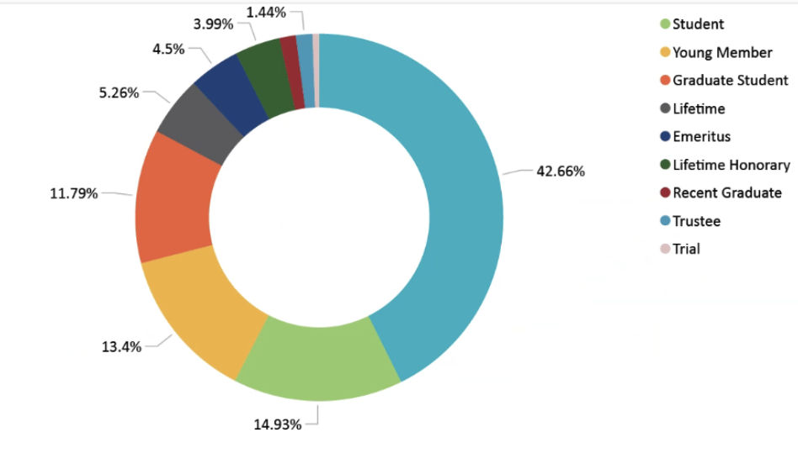
      - Membership over time is consistent
- External Relations Committee Report (PC Simon)
  - Been engaged domestic groups or other professional societies and conferences. Engaging with YMG, etc.
    - With YMG- students want to revamp how we do points of contacts between YMG and the divisions
    - Brought back up the idea of the scholarship
      - Having engagement between YMG + MSTD
    - MiNES is organized by ANS- so we don’t need more connections there
    - TopFuel
      - Whether proceedings will be published
      - We don’t know who will be organizing the next TopFuel
- Awards (Adkins)
  - Put together slides for Awards
    - Sent out to everyone in their email
  - Want to put new definitions of the awards on the website.
    - Needs to contact someone at ANS to get it update
    - Option to have ANS take over the website
  - August 1st is the deadline for winter awards
  - Session chairs to send names to Cindy for people worth of an outstanding presentation
  - Same for papers- literary award (early career)
  - Mishima awarded this meeting- Yay Todd, and the deadline is March 1
  - Scholarship awardee
- Nominating Committee (Aitkaliyeva)
  - Everything went smoothly last year- if anyone is interested in serving as a member of the executive committee
- Old Business (from November 2024)
  - Annabelle brought up the LinkedIn presence.
    - Suggestion to find a student to maintain it
- New Business
- New action items
  - Looking into providing support for conference attendance (waivers, partial waivers, etc)
  - Tapped folks to help with the embedded topical
  - Do we want to have another social at the summer meeting?
    - Yes! Took a vote… all in favor
  - Do we want to start having the embedded topical as a series- every other year.
  - There are no contracts in place – it hasn’t been voted/approved to go down to one meeting. Waiting on the board to decide.
  - Debate on whether we have an embedded topical since we got rid of it to have MiNES
    - They are wanting smaller topicals to co locate or embed
    - Planning to have embedded topical in 2028 winter meeting in Vegas
  - Re-organize committees
- Adjourn

